Project Planning Phase

Project Planning Template (Product Backlog, Sprint Planning, Stories, Story points)

|  |  |
| --- | --- |
| Date | 15 February 2025 |
| Team ID | PNT2025TMID01160 |
| Project Name | Predicting plant growth stages with environmental and management data using Power Bi |
| Maximum Marks | 5 Marks |

**Product Backlog, Sprint Schedule, and Estimation (4 Marks)**

Use the below template to create product backlog and sprint schedule

|  |  |  |  |  |  |  |
| --- | --- | --- | --- | --- | --- | --- |
| **Sprint** | **Functional Requirement (Epic)** | **User Story Number** | **User Story / Task** | **Story Points** | **Priority** | **Team Members** |
| Sprint-1 | Technical Architecture | GMT-22 | Project Flow | 2 | High | Aditya Singh Parmar |
| Sprint-1 | Data Collection & Extraction | GMT-23 | Downloading the dataset | 1 | High | Aditi Arora |
| Sprint-1 | Prepare the data for visualization | GMT-34 | Prepare the data for visualization | 3 | Low | Anjani Kushwaha |
| Sprint-1 | Data Visualization | GMT-27 | Visualization of data | 2 | Medium | Aditya Singh Parmar,  Aditi Arora,  Anjani Kushwaha |
| Sprint-1 | Dashboard | GMT-28 | Responsive and Design of Dashboard | 5 | High | Aditya Singh Parmar,  Aditi Arora,  Anjani Kushwaha,  Amit Yadav |
| Sprint-2 | Design of Report | GMT-32 | Report | 2 | High | Anjani Kushwaha |
| Sprint-2 | Performance Testing | GMT-33 | Utilization of DAX Expression, Number of visualization/Graphs | 3 | High | Aditya Singh Parmar,  Aditi Arora |

**Project Tracker, Velocity & Burndown Chart: (4 Marks)**

|  |  |  |  |  |  |  |
| --- | --- | --- | --- | --- | --- | --- |
| **Sprint** | **Total Story Points** | **Duration** | **Sprint Start Date** | **Sprint End Date (Planned)** | **Story Points Completed (as on Planned End Date)** | **Sprint Release Date (Actual)** |
| Sprint-1 | 13 | 3 Days | 07 Feb 2025 | 09 Feb 2025 | 13 | 10 Feb 2025 |
| Sprint-2 | 05 | 2 Days | 10 Feb 2025 | 11 Feb 2025 | 05 | 11 Feb 2025 |

Velocity:

Sprint 1 = 13

Sprint 2 = 05

Velocity= Total Story Points Completed/ Number of Sprints Total story Points= 13+5 =18

No of Sprints= 2 Velocity = (13+5)/2= 18/2

09(Story Points per Sprint)

**Your team’s velocity is 9 Story Points per Sprint.**

**Burndown Chart:**

**Sprint 1:**

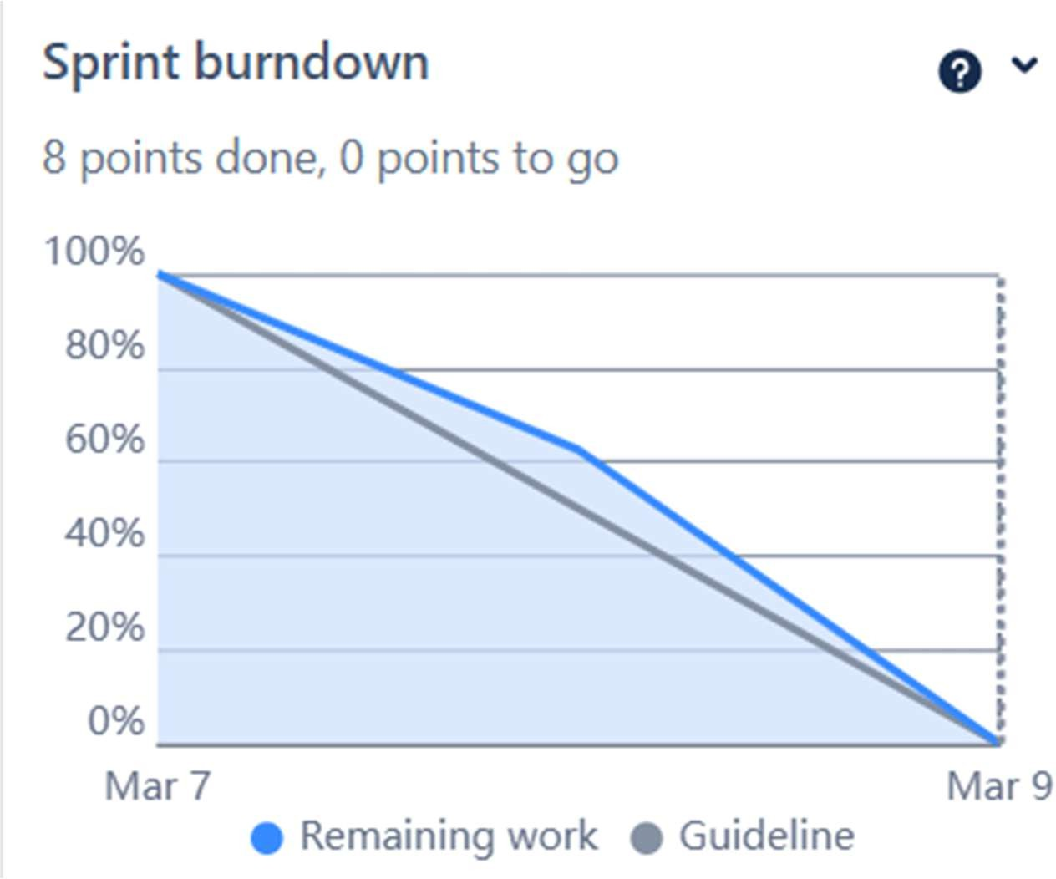

**Sprint 2:**

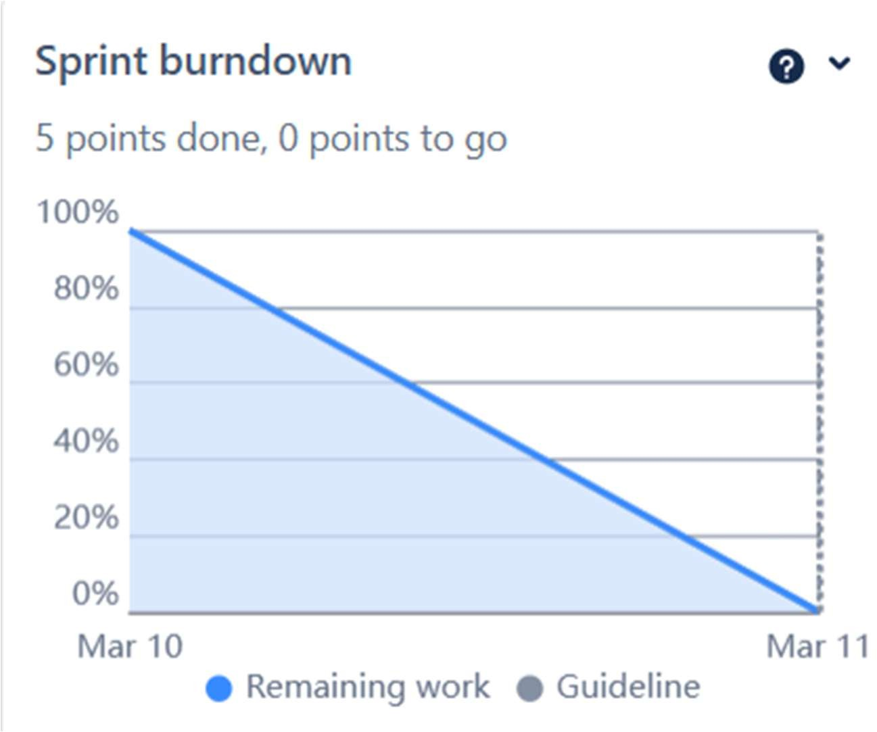

Timeline:

